MobileSoftware Development

Assignment 1: Documentation

Coffee Beans



C14706715

Jake Young

DT282/3

Table of Contents

Introduction 3

Functionality: 3

Timing System 3

User 3

Mapping System 3

How To Page 3

Use Case Diagram 4

Screen Flow 5

Database 6

Description 6

Tables and Fields 6

# Introduction

This application is an assignment for Mobile Software Development.

This application is called Coffee Beans. Its purpose is to make Coffee enthusiasts lives that bit more easier. The finished product should have plenty of essential functionality.

Throughout this assignment I am going to be constantly saving my work through the user of GitHub. My Git repository is <https://github.com/C14706715/Mobile-Software-Development>

Here you will find all my commits as well as the complete project.

I have used mainly Android Developer for tips on how to use different functionality.

I also included Google Maps library in my project to assist me creating a mapping system in my application.

## Functionality:

### Timing System

This is a timer which is used to help users time the amount of time it should take to leave your coffee grind to brew in a cafeteria in order to retrieve the optimum taste.

This page will also have calculator functionality. It will calculate the length of time you need to leave your coffee grind to brew depending on the amount of grams used. I also want to implement a short coffee brewing video to play whilst the timer is counting down.

### User

I intend on creating profiles for each user of the app. In order to use the app you must either login or signup. The details needed will be the users name, email, password and age. This will be sent to my database using MySQL.

### Mapping System

This app will also contain Google Maps functionality. I want the users to be able to see coffee shops in their area. This should automatically be generated when the user clicks to open the Mapping page.

### How To Page

Another piece I would like to implement would be a how to page. This page should describe how to make many different great cups of coffee i.e. Latte, Cappuccino, Cortado etc.

# Use Case Diagram

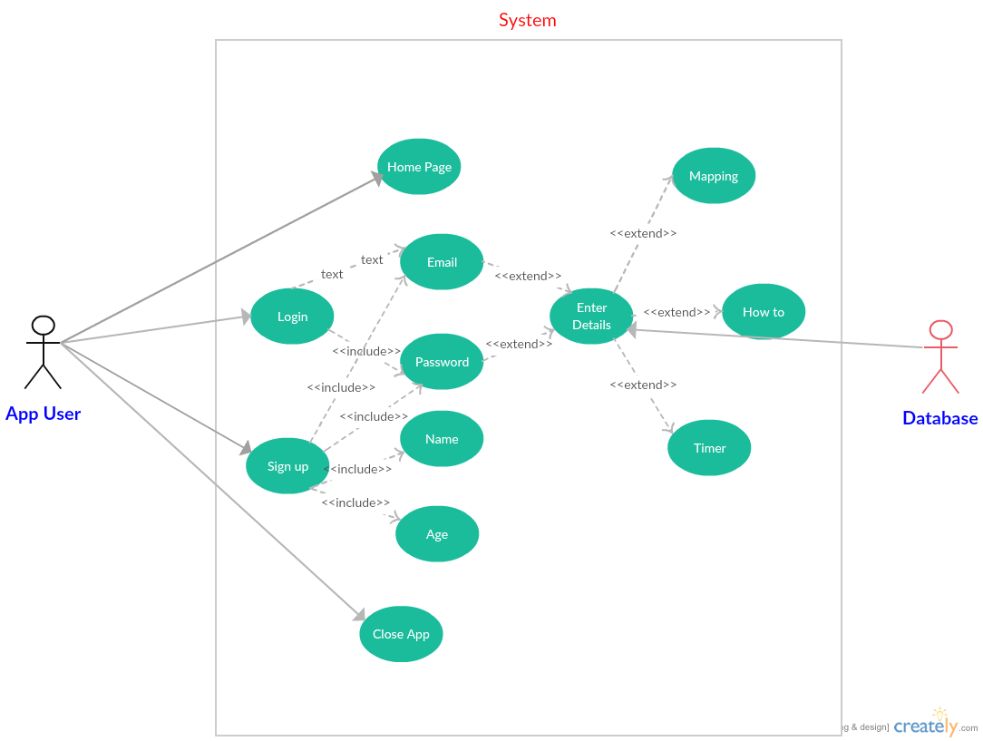

# Screen Flow

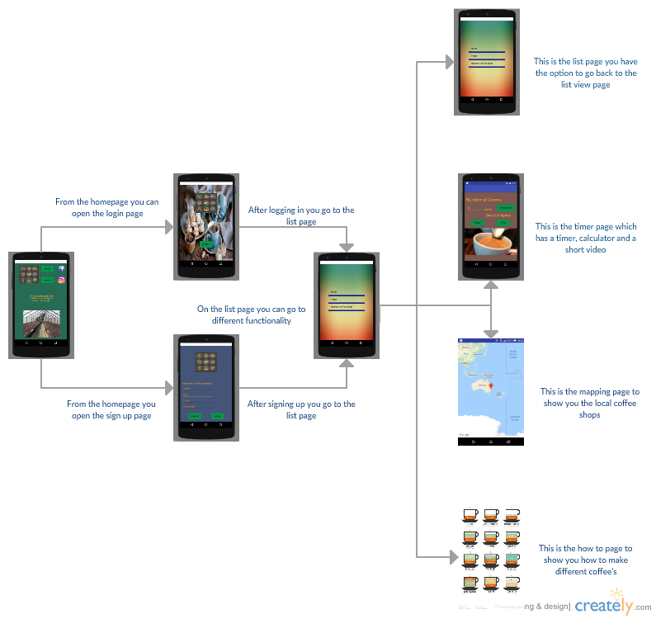

# Database

## Description

This database is very simplistic it simply will hold the users name, age, email and password. This data will be collected when the user first signs up in the application. Then upon further logging in the user will only need to enter their email and password. Their data will be saved in my database created through MySQL.

## 

## Tables and Fields

This is an example of what my table and fields in my database would look like.

Note: These are not real users in the database.

|  |  |  |  |
| --- | --- | --- | --- |
| Name | Age | Email | Password |
| Jake | 21 | [Jake1995young@gmail.com](mailto:Jake1995young@gmail.com) | Jake123 |
| John | 22 | [John@gmail.com](mailto:John@gmail.com) | John123 |
| Eryk | 21 | [Eryk@hotmail.com](mailto:Eryk@hotmail.com) | Eryk321 |
| Pamela | 20 | [Pamela@outlook.ie](mailto:Pamela@outlook.ie) | PamSab |